Ooh La La! Vintage – Fashion Archive & Consultations
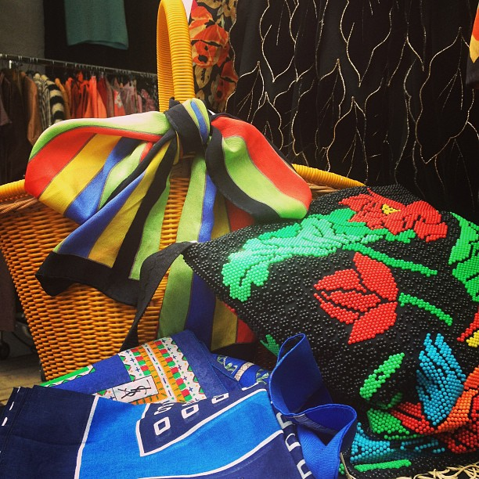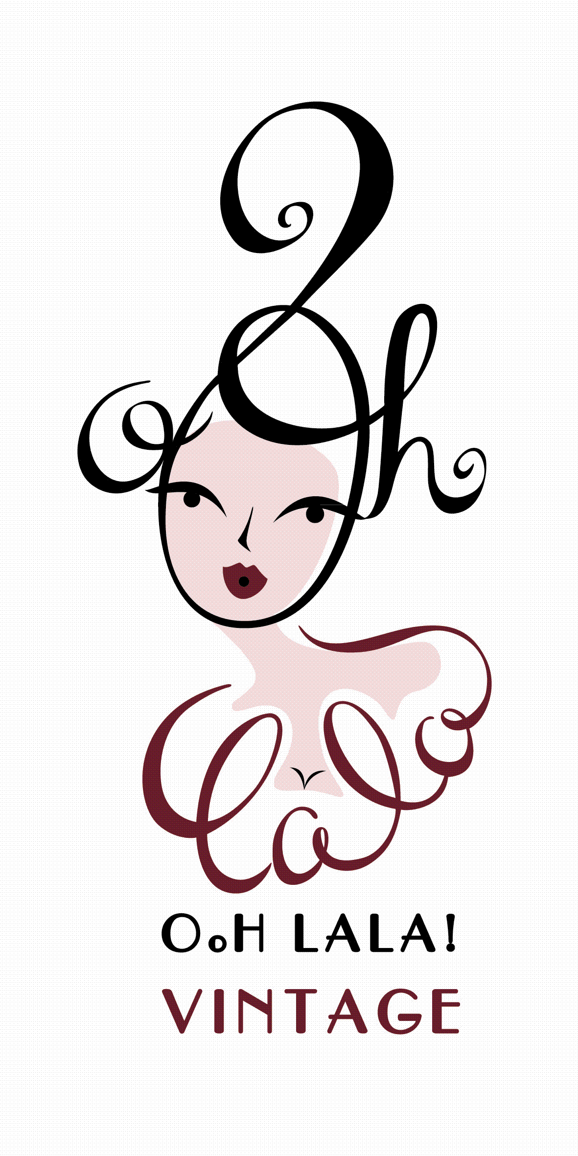

Ooh La La! Vintage caters discreetly for clients who are looking for unusual, collectable one-off items:

- costume departments who are sourcing era based items for film and TV
- designers looking to find inspirational designs
- stylists looking for fashion shoot ideas and props

After 12 years in Paris the company is a go to for sourcing French vintage clothes, shoes, accessories and objects in the capital. Selections are made according to quality, attention to detail and often reflect future catwalk trends. Items date from the early 1900's to the 1980's, and there is a regular and changing stock of garments where the emphasis is on fashion, individuality and plain instinct!
Design clients include: Marni, Marc Jacobs, Vanessa Bruno, Chanel, Isabel Marant, Nina Ricci, Lacroix, Topshop, Warehouse, People Tree, Hoss Intropia, Jill Stuart, Erdem, Cavalli, Marks & Spencers, Monsoon, Topshop, Acne, The Kooples, And Other Stories, Miss Selfridge, Oasis, ASOS, Alice & Olivia, Rachel Roy, Sonia Rikiel and Lulu GuinessWhere possible we try to show exclusive pieces gathered for the purpose of seasonal storyboard briefings. These are welcome a couple of weeks in advance and are kept confidential at all times.
Appointments can be arranged in Paris at the Ooh La La! Vintage home studio reached directly from Gare de Nord door to door on Line H in half an hour. Alternatively London appointments can be made around monthly vintage fairs such as Frock Me, Chelsea, Hammersmith Vintage Fair and Portobello Market.
Contact: Tara Munro for appointments on 00 33 684 765 865

