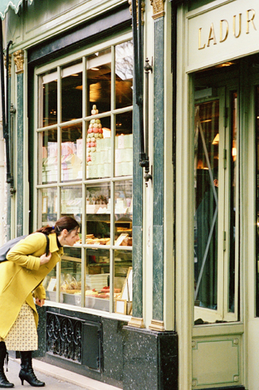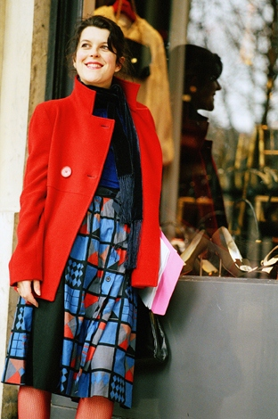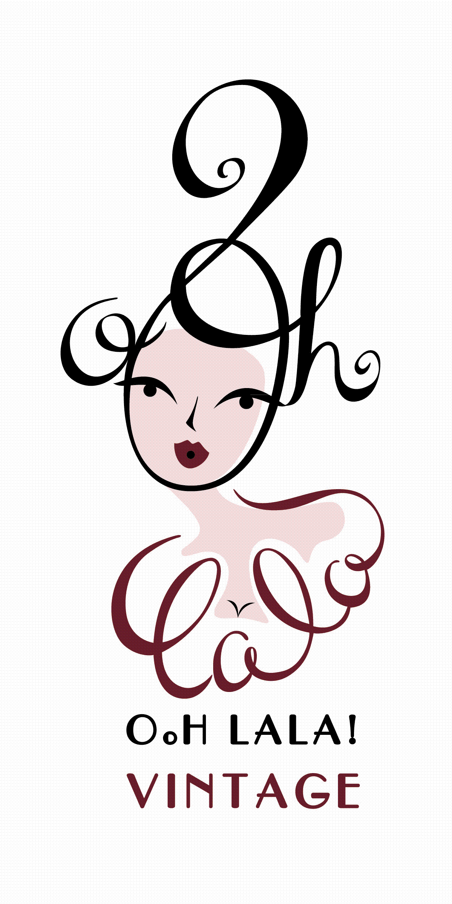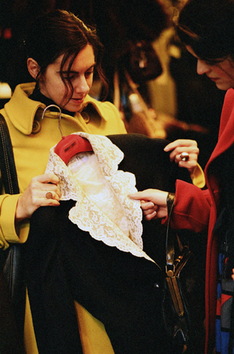

Ooh La La! Vintage Shopping Tours

Allow Ooh La La! Vintage to take you back in time through the capital's best vintage addresses: from haberdasheries and belle epoque shopping arcades to quirky vintage boutiques and chic private salons. Be introduced to lesser known addresses and their charismatic sellers and allow the vintage passionista to seek out your vintage desires. The experience will also enable you to enjoy an insight into the last century of fashion history and insider tips on what you should be looking for before a final stop at an elegant salon du the tea or cosy hideaway to indulge in something truly scrumptious and savour your newly acquired purchases. Ooh La La! Vintage will also help you navigate your way around the language, the price (if necessary) and present each vintage seeker with a carnet of addresses..
3 hr packages start from 75 euros pp. Ask also about specific shopping desires? We’ll be pleased to customise a package just for you!

Shopping Tour One - Palais Royal/Opera/Concorde
Highlights:
Boutiques filled with brands such as Dior, Chanel and Givenchy and more unusual finds. A tailor made tour will take you to other specialist stores spanning round into Opera where our voyage back in time will take us through 19th century shopping galleries filled with little antique shops, book shops, tearooms and authentic brasseries and haberdasheries. Last stop Angelina's or Laduree where you can rub shoulders with the ghosts of Audrey and Coco whilst sipping hot chocolate and macaroons in authentic ambiance.

Shopping Tour Two - Bastille and La Marais
Highlights:
A meandering tour around the village St Paul, Le Marais and beyond into Bastille winding through the medieval streets of Paris will allow you to discover some of the most popular and well priced vintage boutiques in Paris..Don't worry though, shoppers with Tara will be taken on the best days in time for new stock, less crowds and the best finds as well as being shown a few out of the way places. What are you looking for?.. a wartime miltary jacket? a crazy pyschadelic dress from the sixties or a divine Lyon silk peignor?..Ooh La La! Vintage will help you find it....Final stop a super sweet little vintage tearoom for tea and stylish people watching.

The shopping tour is based on a minimum of two people at 75 Euros per person.
This includes a 3hr experience: itineraries mentioned above can be tailored to include designer boutiques or specific requests.
Other additional options include: vintage car tours, vintage hair, make up and photography sessions.
Prices on request

